 

**MUHAMMAD TAHA (211660)**

**MUHAMMAD AHSON ANWAAR (217505)**

**MUHAMMAD USAMA (240509)**

**MECHANICAL ENGINEERING**

**DE-39(B)**

**MECHANICS OF MATERIALS - I**

**DESIGN PROJECT**

**DESIGN OF DRILL BIT**

**OBJECTIVE:**

To design a drill bit used in lathe machine as a cutting tool.

**INTRODUCTION:**

A lathe is a machine tool that rotates a workpiece about an axis of rotation to perform various operations such as cutting, sanding, knurling, drilling, deformation, facing, and turning, with tools that are applied to the workpiece to create an object with symmetry about that axis. Here we consider drilling only. The rotating workpiece is brought in contact with the drill bit to cut through the workpiece. This rotating workpiece induces torsional loading in the drill bit generating stresses in the drill bit and deforming the drill bit.

**OUR APPROACH:**

* Make suitable assumptions.
* Choose a suitable material for the drill bit
* Calculate Maximum Torque produced in the drill bit due to rotation of workpiece by the lathe machine
* Calculate the maximum shear stress that the material can withstand and apply Factor of Safety to avoid failure
* With the maximum shear stress and the maximum Torsional deformation equations calculate the minimum diameter of the drill bit that is within the safe limit

**ASSUMPTIONS:**

* We assume that the rotating workpiece is brought into the drill bit very slowly with negligible force so that compressive forces may be neglected and thus the cutting of the material is due to torsional load only.
* The geometry of the drill bit is approximated to be circular.

**SPECIFICATIONS OF THE LATHE MACHINE:**

* RPM Range: 200-3000 rpm
* Power : 150 W

**MATERIAL SELECTED:**

**M2 Molybdenum High Speed Tool Steel:**

Used in high speed tool and cutting applications such as drills, milling processes, reamers, etc. Mo and W content promotes toughness and aids cutting properties, but requires more precise hardening conditions and caution about overheating. Quench via oil, air, or salt bath.

**Shear Yield Strength: 1625 MPa**

**Average Shear Modulus: 90 GPa**

**CALCULATIONS:**

**Free body diagram:**

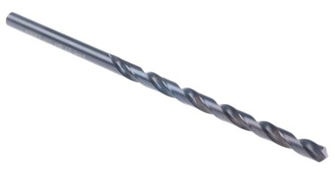

Depth of penetration

TORSIONAL REACTION WHERE THE DRILL BIT IS CLAMPED IN THE LATHE MACHINE

DISTRIBUTED TORSIONAL LOAD DUE TO THE ROTATION OF WORKPIECE AND PENETRATION OF DRILL BIT INTO THE WORKIECE